**VJWTSS08190012**

**CODECAMP DAY2**

**Program 1:** The total distance traveled by vehicle

**Ans:**

#include<stdio.h>

int main()

{

int u,a,t;

float x;

printf("enter the values of\n intvelocity\n acceleration\n time\n");

scanf("%d %d %d",&u,&a,&t);

x=u*t+(0.5*a*(t*t));

printf("the value of distance is: %f\n",x);

return 0;

}

Output:

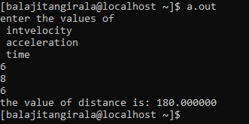

**Program 2:** Guess a number between 1 and 100 in your mind.

**Ans :**

#include <stdio.h>

int main()

{

int num, guess, tries = 0;

srand(time(0)); /* seed random number generator */

num = rand() % 100 + 1; /* random number between 1 and 100 */

printf("Guess My Number Game\n\n");

do

{

printf("Enter a guess between 1 and 100 : ");

scanf("%d", &guess);

tries++;

if (guess > num)

{

printf("Too high!\n\n");

}

else if (guess < num)

{

printf("Too low!\n\n");

}

else

{

printf("\nCorrect! You got it in %d guesses!\n", tries);

}

}while (guess != num);

return 0;

}

**Output :**

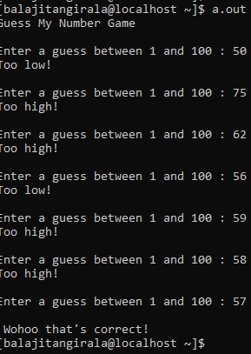

**Program 3 (a):** Write a c program to perform to mask the nth bit using logical operators

**Ans :**

#include <stdio.h>

#include <stdio.h>

int main()

{

int num, n, newNum;

printf("Enter any number: ");

scanf("%d", &num);

printf("Enter nth bit to set (0-31): ");

scanf("%d", &n);

newNum = (1 << n) | num;

printf("Bit set successfully.\n\n");

printf("Number before setting %d bit: %d (in decimal)\n", n, num);

printf("Number after setting %d bit: %d (in decimal)\n", n, newNum);

return 0;

}

**Output :**

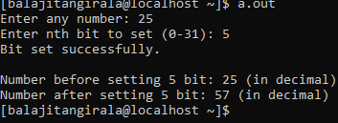

**Program 3 (b):** Write a c program to perform to check a bit and set a bit if it is not set.

**Ans :**

#include <stdio.h>

int main()

{

int NUM;

int N;

printf("Enter an 8 bits integer number: ");

scanf("%d",&NUM);

printf("Now, enter a bit number (from 0 to 7) to check, whether it is SET or not: ");

scanf("%d",&N);

if(NUM & (1<<N))

printf("Bit number %d is SET in number %d.\n",N,NUM);

else

printf("Bit number %d is not SET in number %d.\n",N,NUM);

return 0;

}

**Output :**

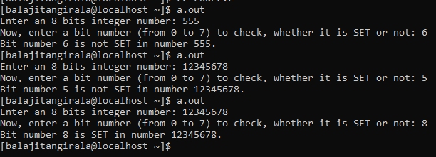

**Program 4 (a):**  Write a program to search in a char string for the char which occurs maximum number of times.

**Ans :**

#include <stdio.h>

#define size 100

#define chars 200

int main()

{

char str[size];

int freq[chars];

int i = 0, max;

int ascii;

printf("Enter any string: ");

gets(str);

for(i=0; i<chars; i++)

{

freq[i] = 0;

}

i=0;

while(str[i] != '\0')

{

ascii = (int)str[i];

freq[ascii] += 1;

i++;

}

max = 0;

for(i=0; i<chars; i++)

{

if(freq[i] > freq[max])

max = i;

}

printf("Maximum occurring character is '%c'\n", max);

return 0;

}

**Output :**

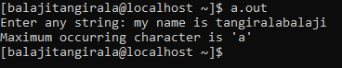

**Program 4(b) :** Write a program to find the number of letters in a string.

**Ans :**

#include<stdio.h>

int main()

{

char str[100];

int i=0,a=0;

printf("enter the string :");

gets(str);

while (str[i]!='\0')

{

if(str[i]==' ');

else

a++;

i++;

}

printf("Number of letters in a string are %d\n",a);

return 0;

}

**Output :**

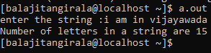

**Program 10:** To insert a sub-string in to a given main string from a given position.

**Ans :**

#include <stdio.h>

#include <string.h>

main()

{

char a[10], b[10],c[10];

int d=0,e=0,i=0,f=0;

int x,g,s,n,o;

printf("Enter First String:");

gets(a);

printf("Enter Second String:");

gets(b);

printf("Enter the position where the item has to be inserted: ");

scanf("%d",&d);

e = strlen(a);

n = strlen(b);

i=0;

while(i <= e)

{

c[i]=a[i];

i++;

}

s = n+e;

o = d+n;

for(i=d;i<s;i++)

{

x = c[i];

if(f<n)

{

a[i] = b[f];

f=f+1;

}

a[o]=x;

o=o+1;

}

printf("%s", a);

getchar();

}

**Output :**

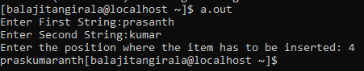

**Program 11 :** Write a c program to store n number of scholar records and print the records from 1 to n and n to 1

**Ans :**

#include<stdio.h>

int main()

{

int id[10],i,n;

char name[10][20];

printf("enter no of scholars\n");

scanf("%d",&n);

for(i=0;i<n;i++)

{

printf("enter id of scholar\n");

scanf("%d",&id[i]);

printf("enter names of scholars\n");

getchar();

scanf("%s",name[i]);

}

for(i=0;i<n;i++)

{

printf("scholar id is %d\n",id[i]);

printf("name of scholar is %s\n",name[i]);

}

i--;

for(;i>=0;i--)

{

printf("scholar id is %d\n",id[i]);

printf("name of scholar is %s\n",name[i]);

}

}

**Output :**

